***GARAGE MANAGEMENT SYSTEM***

**College Name: KARUPPANNAN MARIAPPAN COLLEGE**

**College Code: bru3s**

**TEAM ID:** **NM2025TMID28606**

**TEAM MEMBERS:**

**Team Leader: A.ESTHER KIRUBA**

**Email:** kirubaesther2@gmail.com

**Team Member1: J.HARI**

**Email:** hariprasanth3556@gmail.com

**Team Member2: R.DHARMA**

**Email:** dcvijay261@gmail.com

**Team Member3: K.KAVIN KUMAR**

**Email:** kavinkumarkd2816@gmail.com

**Team Member4: M.RAMYA**

**Email:** ramyamunusami25@gmail.com

**1.INTRODUCTION**

**1.1 Project Overview**

The Garage Management System is a **comprehensive webbased tool designed to streamline and optimize the operations of a garage**. Built on the Salesforce platform, this system offers a centralized platform for managing vehicle records, service appointments, billing, and customer feedback.

**1.2 Purpose**

The system leverages Salesforce’s features like custom objects, reports, dashboards, and automation tools to enhance the overall efficiency of managing a garage. This project aims to **reduce operational delays, improve customer experience, and ensure real-time tracking of all service activities.**

**DEVELOPMENT**  **PHASE**

**●** **Creating Developer Account:**

By using this URL - <https://developer.salesforce.com/signup>

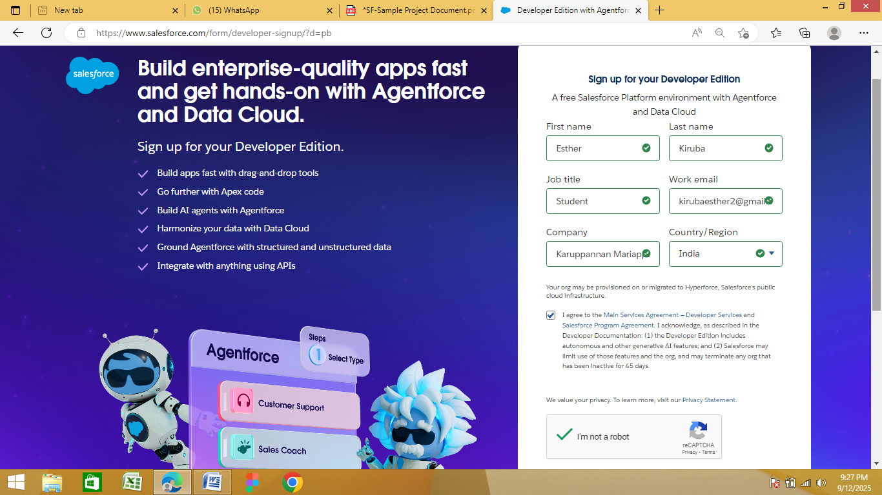

**●** **Account activation:**

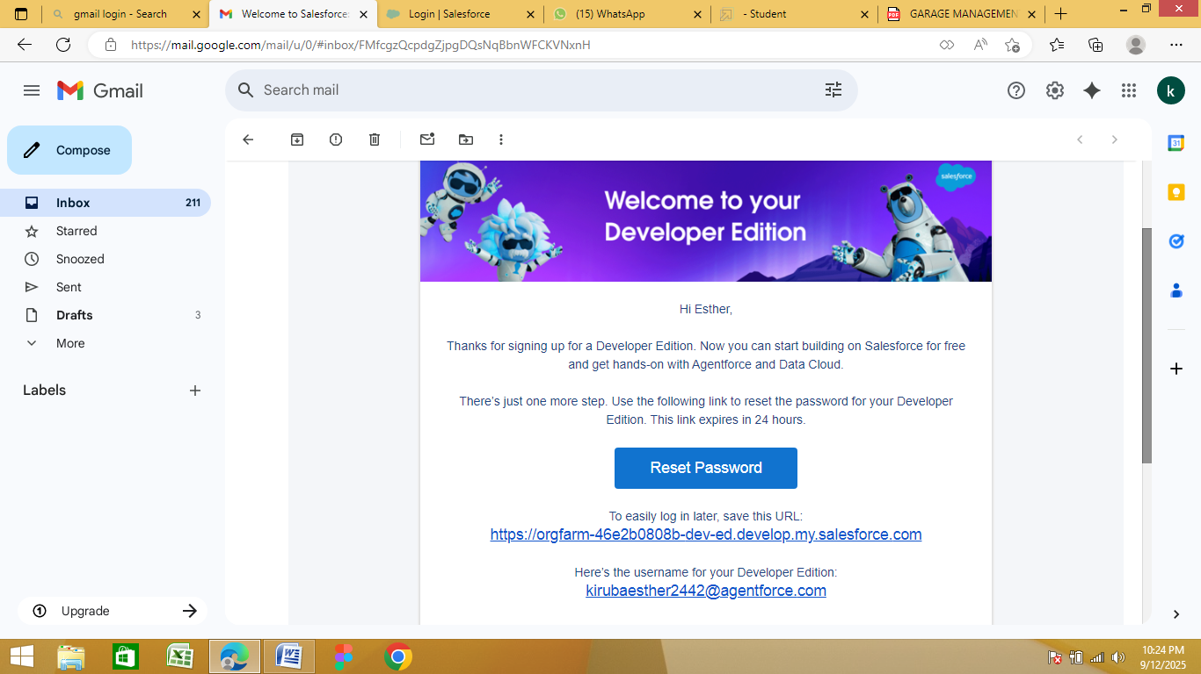

**●Create Customer Details Object:**

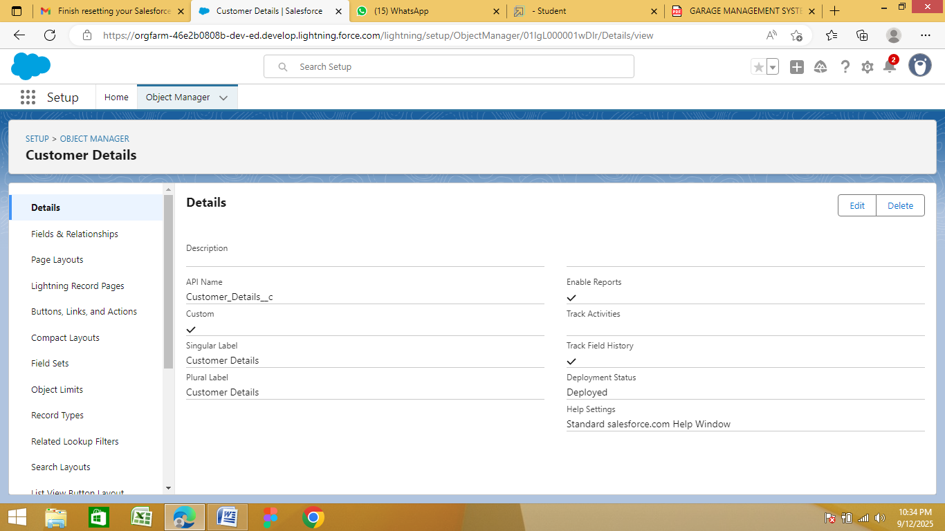

**●Create Appointment Object:**

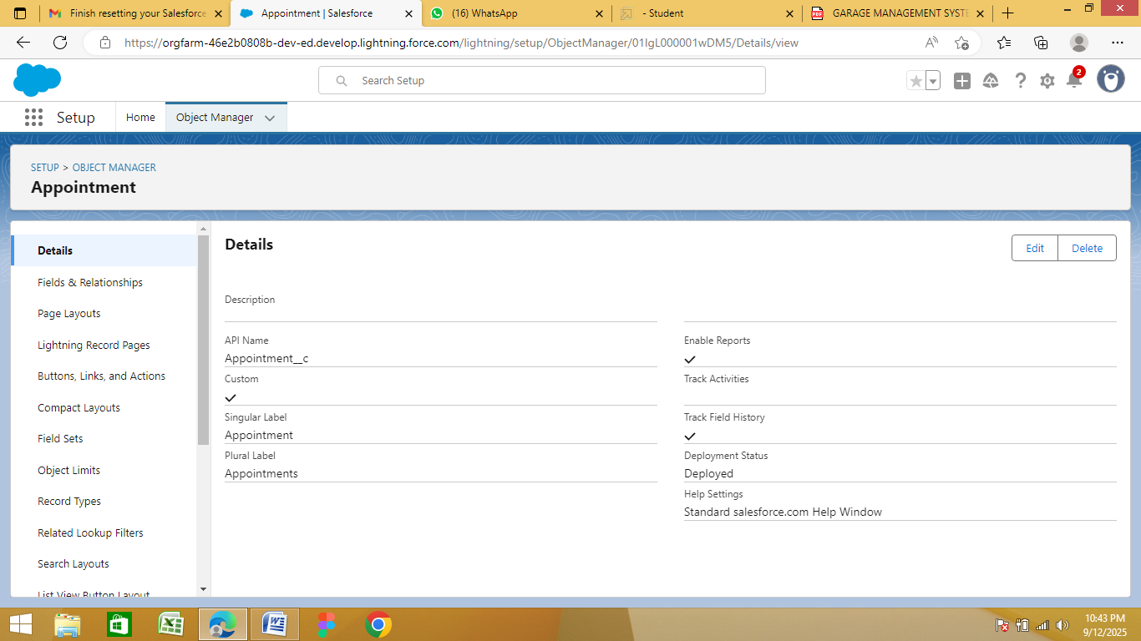

**●Create Service Records Object:**

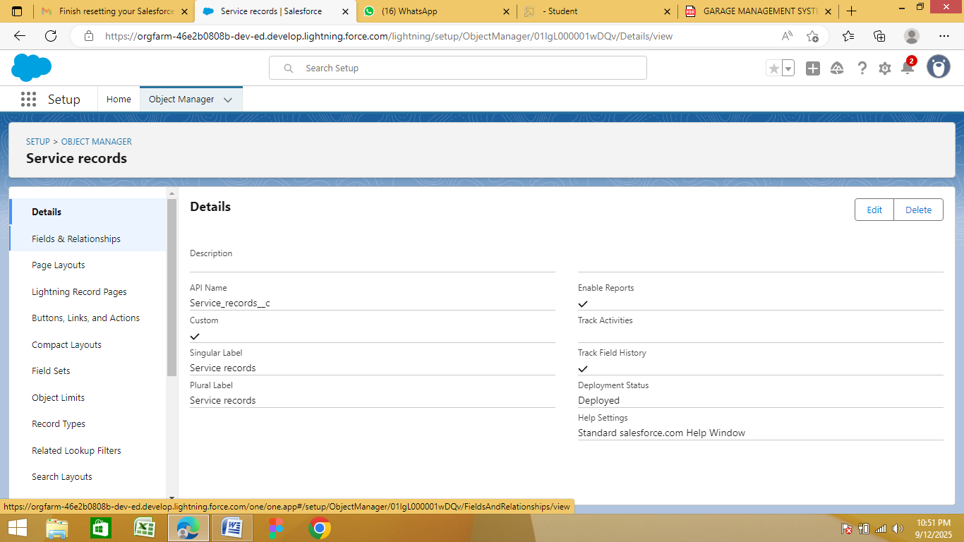

**●Create Billing Details and Feedback Object:**

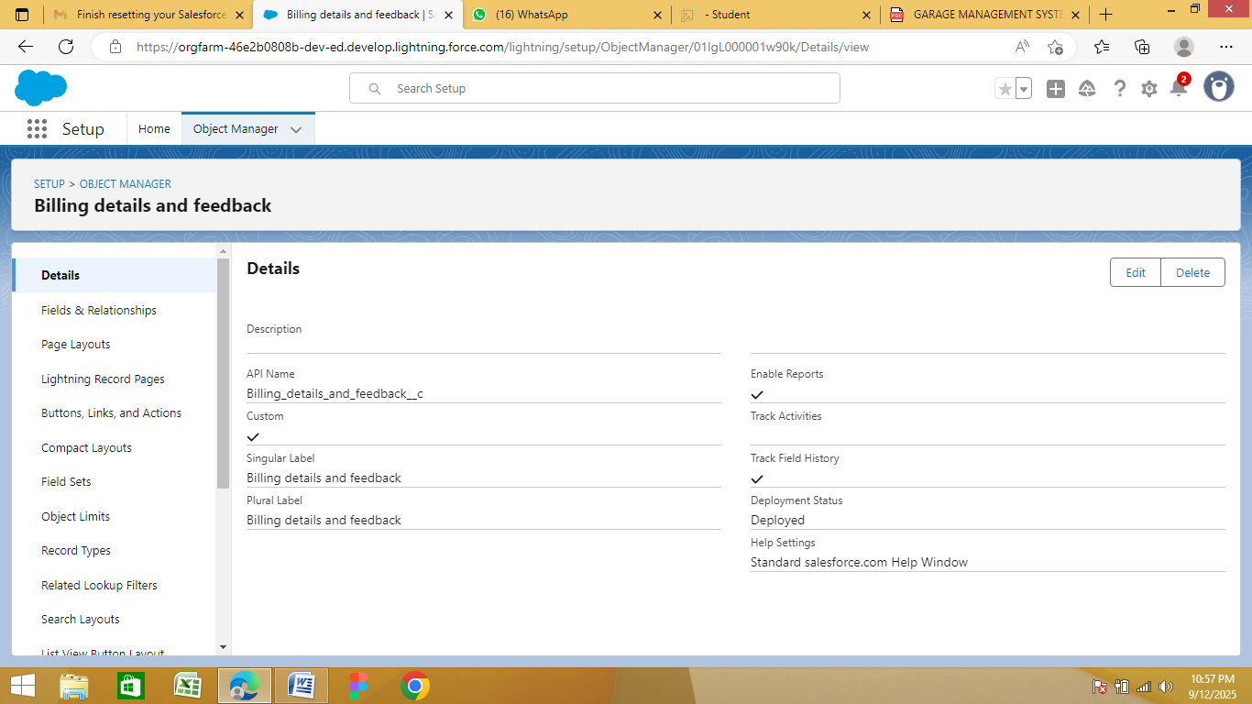

**●Creating a Custom Tab:**

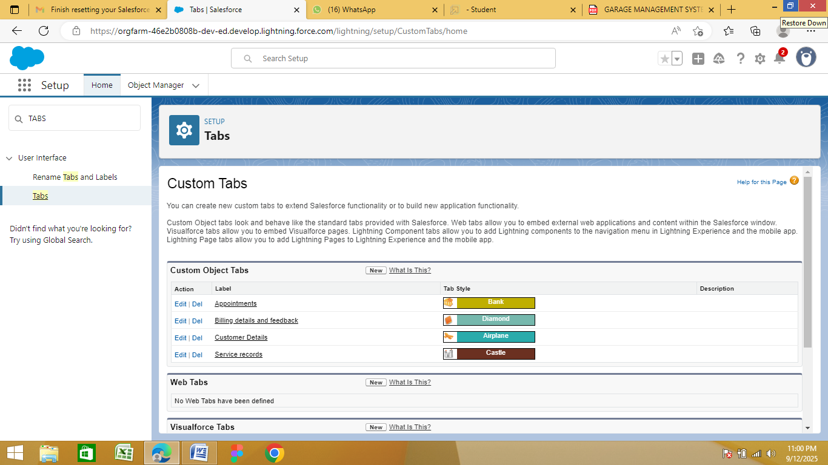

**●Create a Lightning App: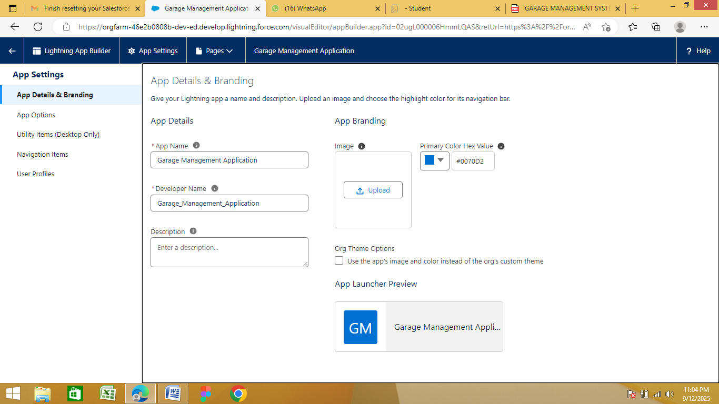 ●Creation of Fields for the Customer Details Object:**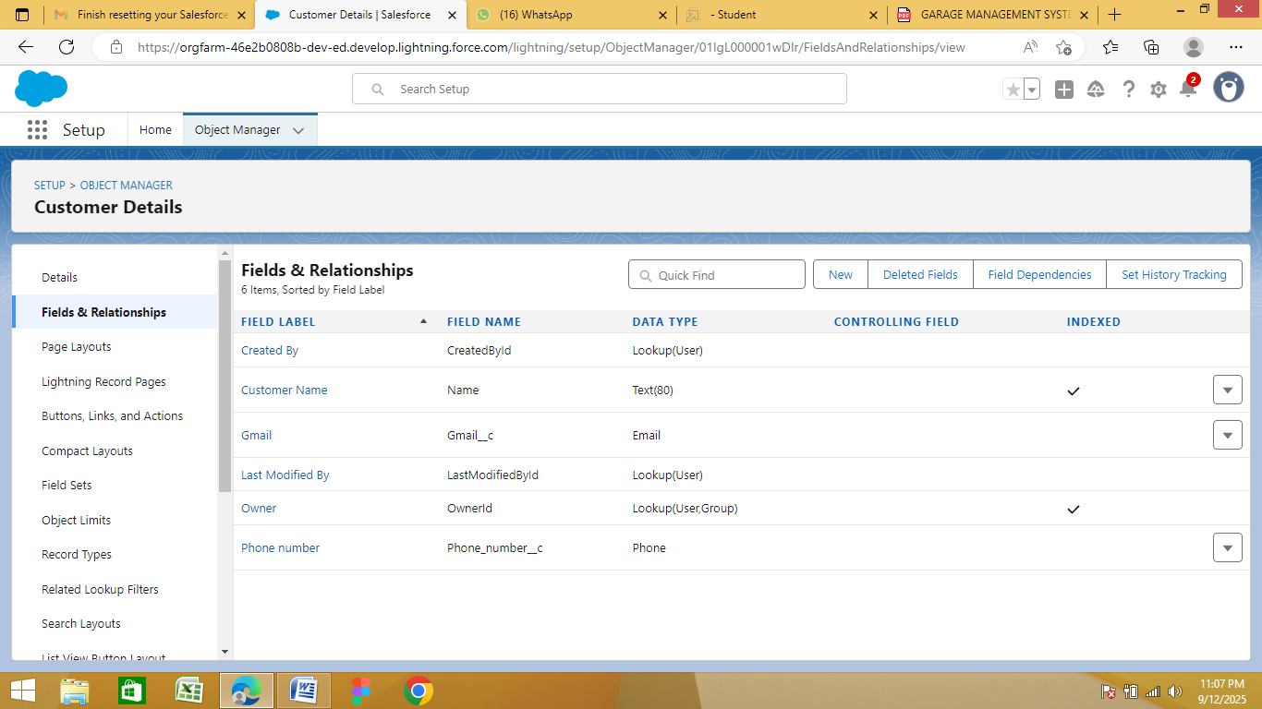

**●Creation of Lookup Fields:**

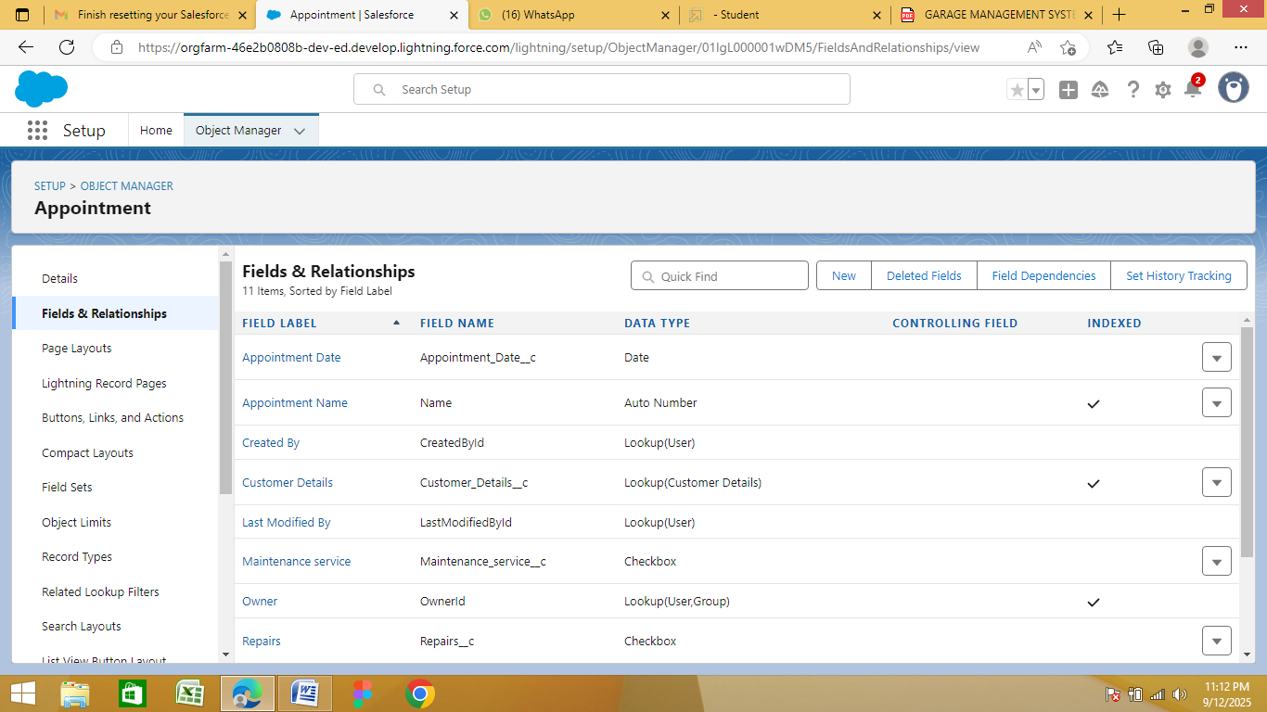

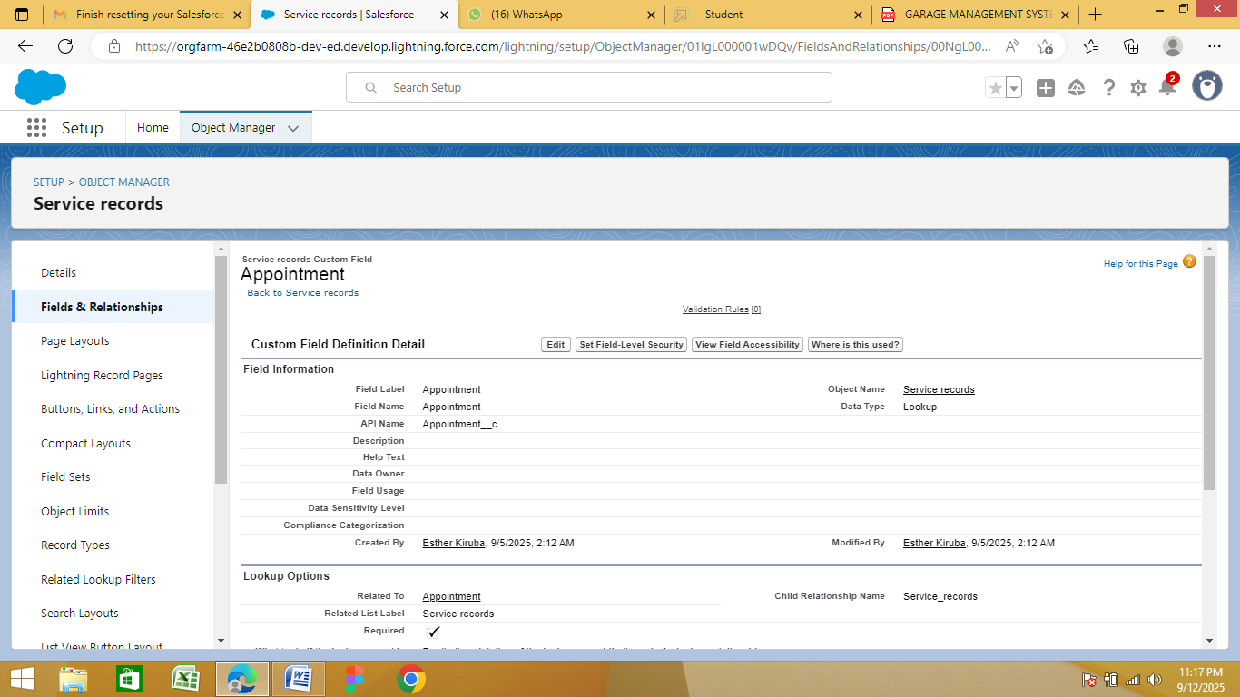

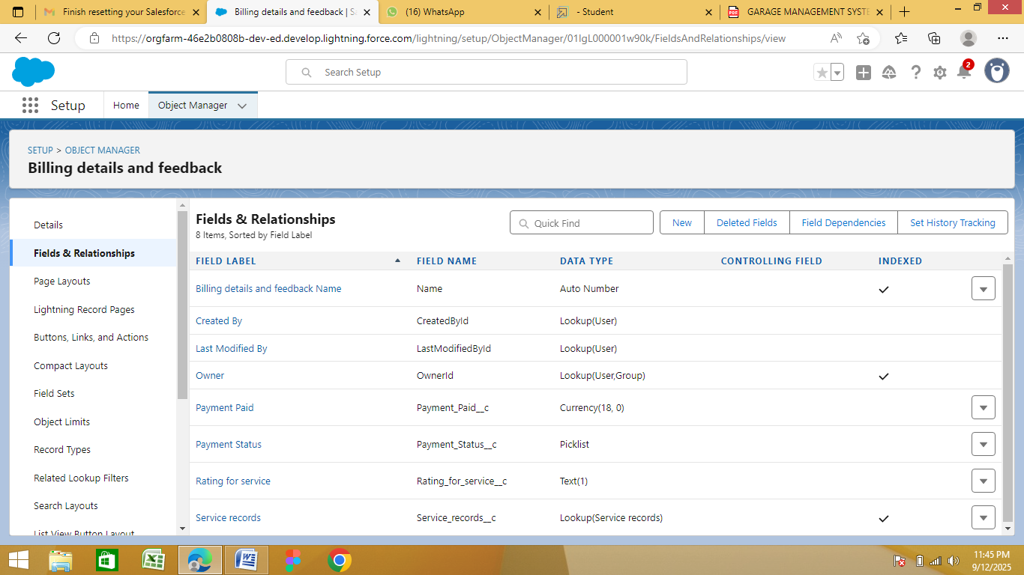

**●Creation of Checkbox Fields:**

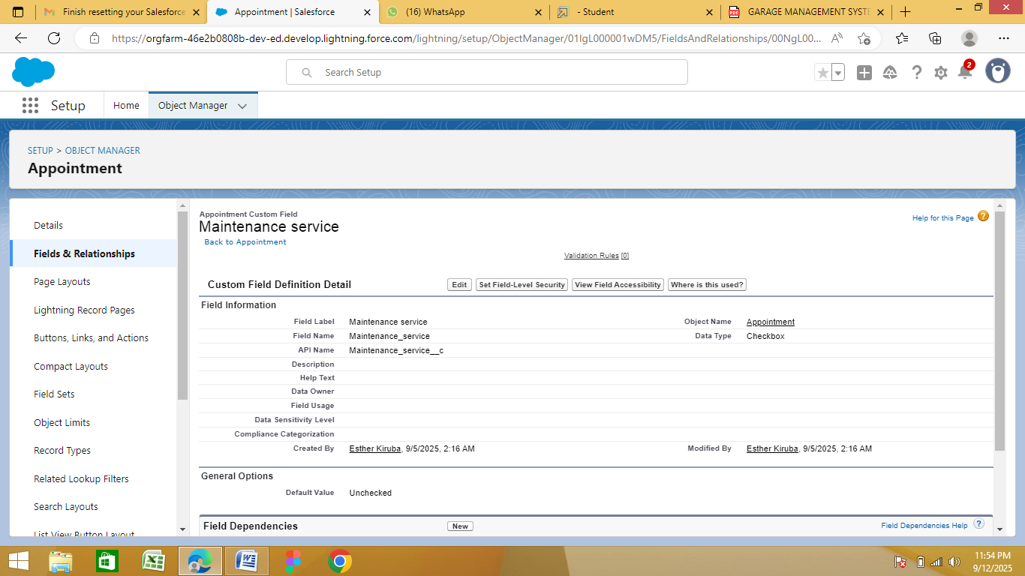

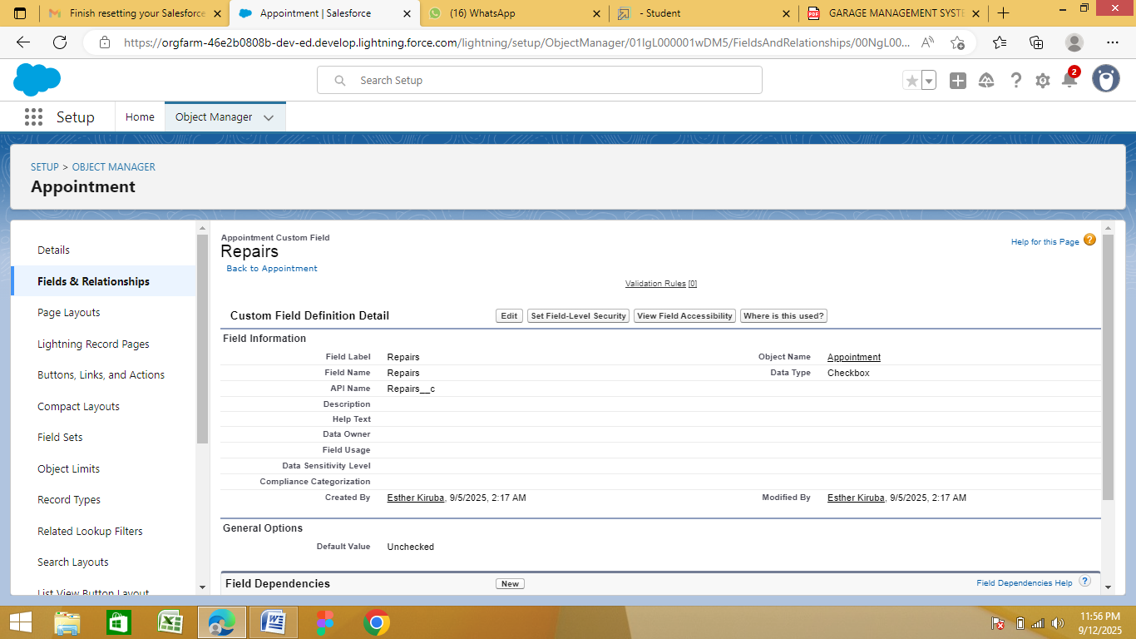

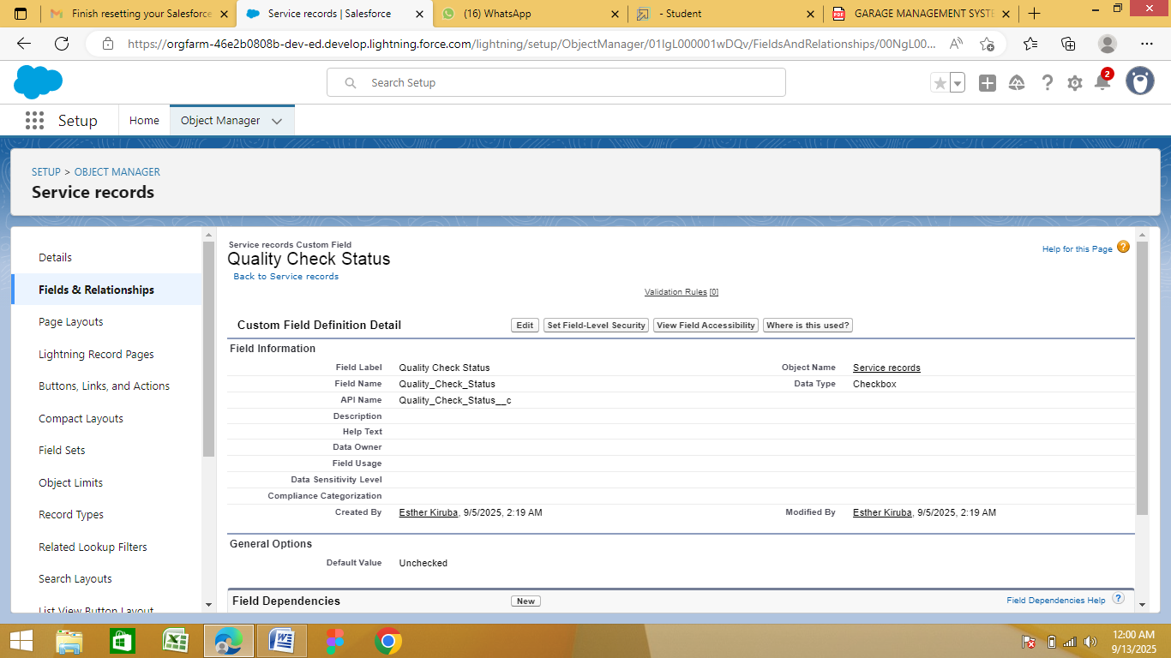

**●Creation of Date Fields:**

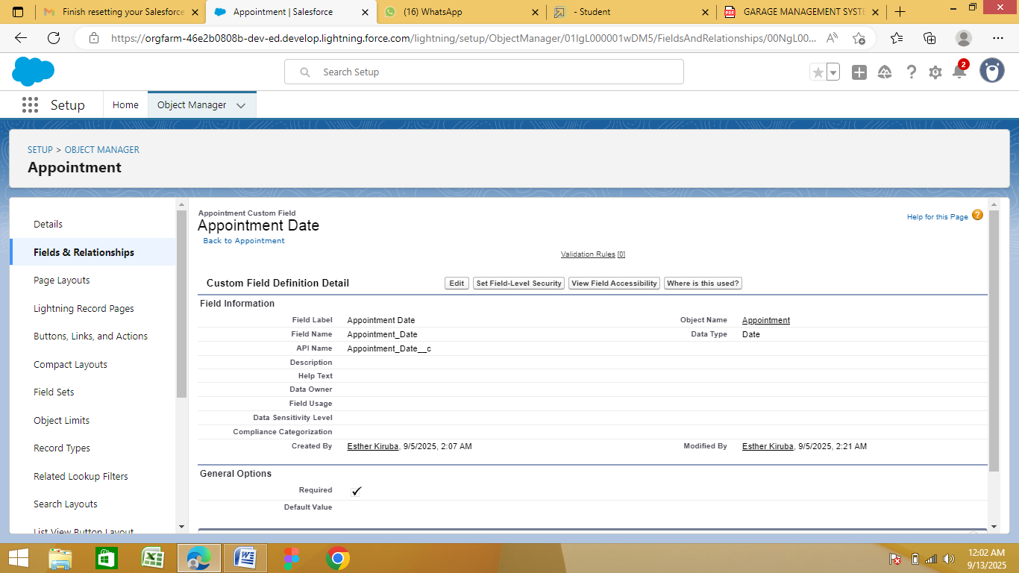

**●Creation of Currency Fields:**

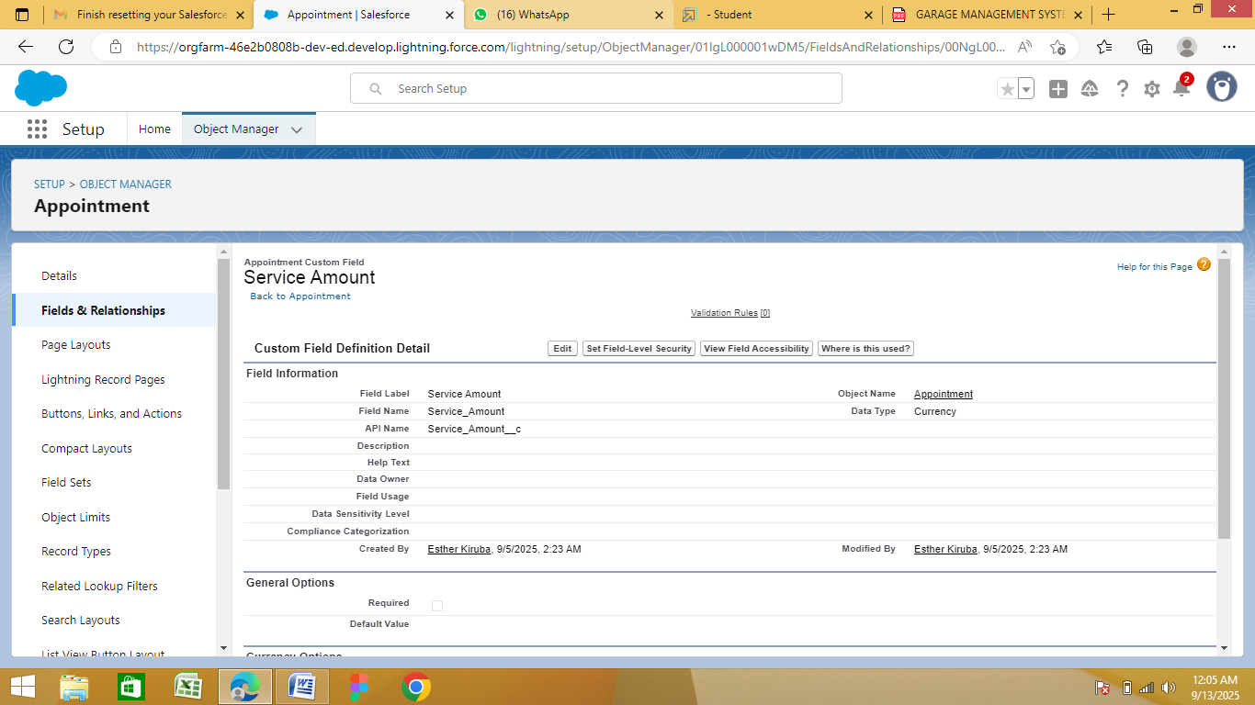

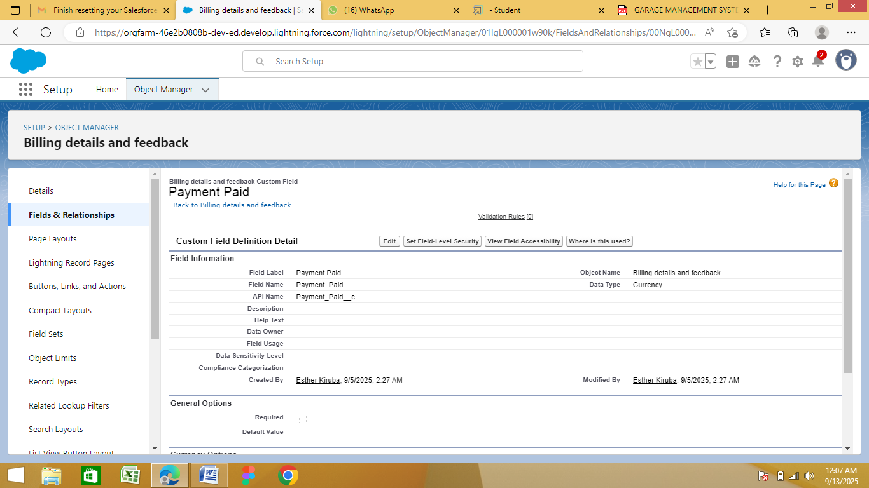

**●Creation of Text Fields:**

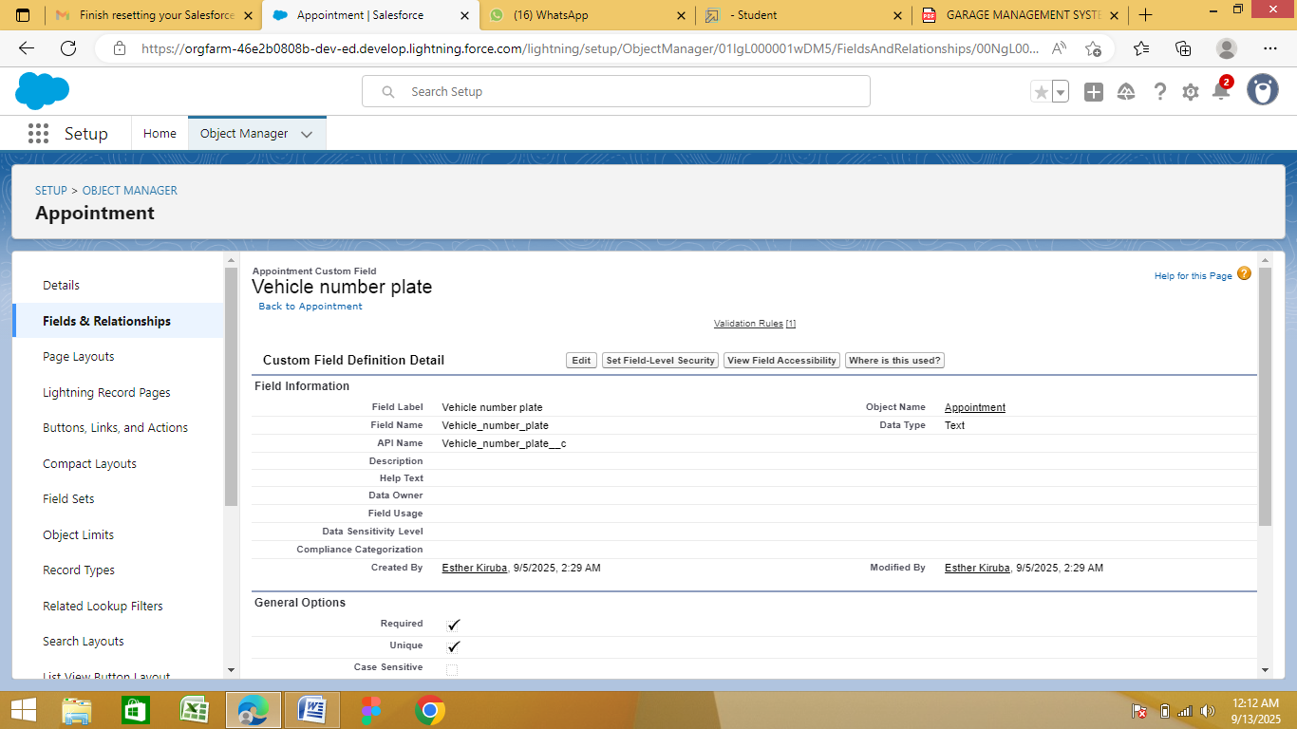

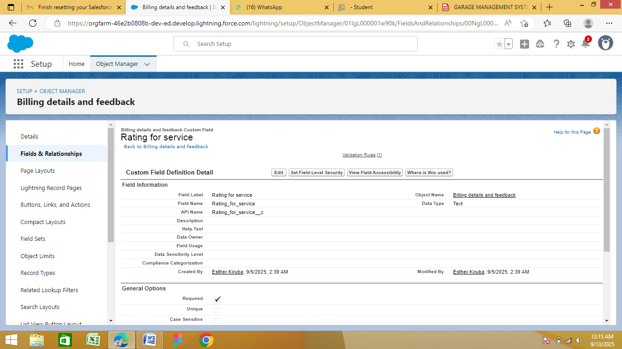

**●Creation of Picklist Fields:**

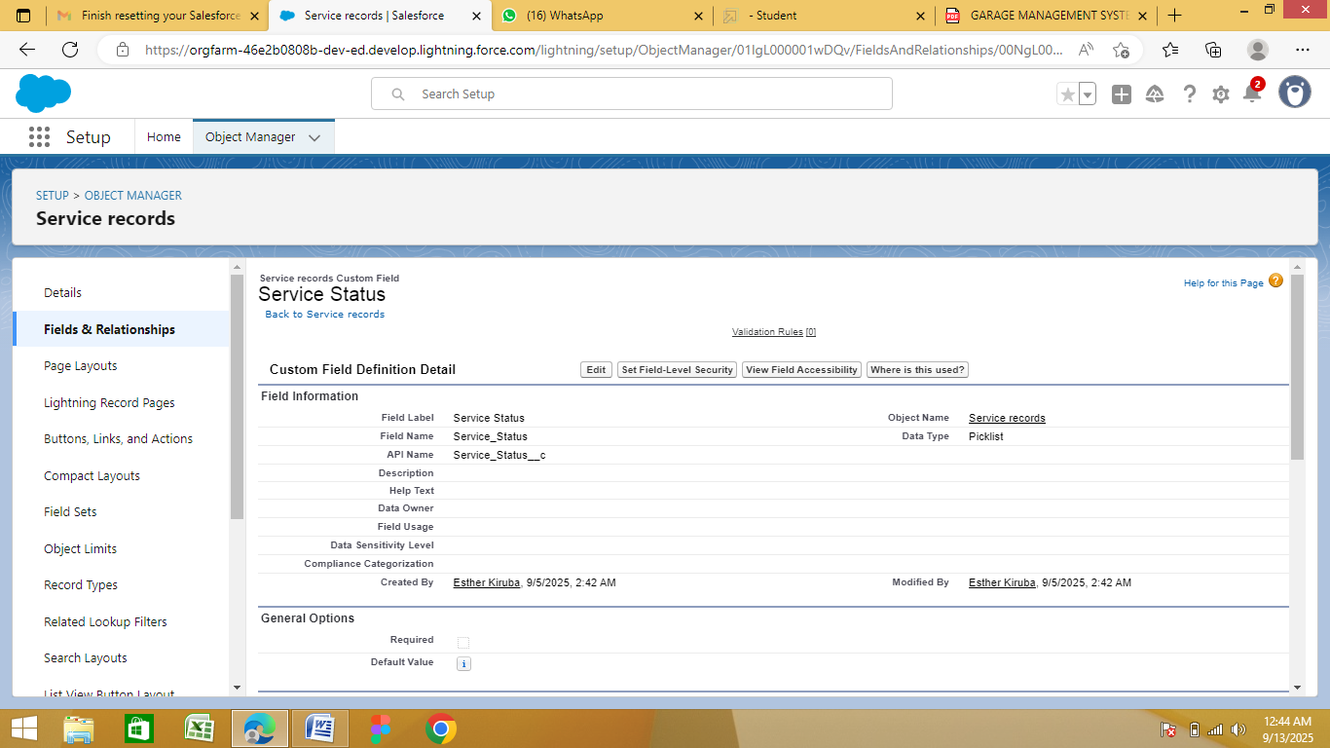

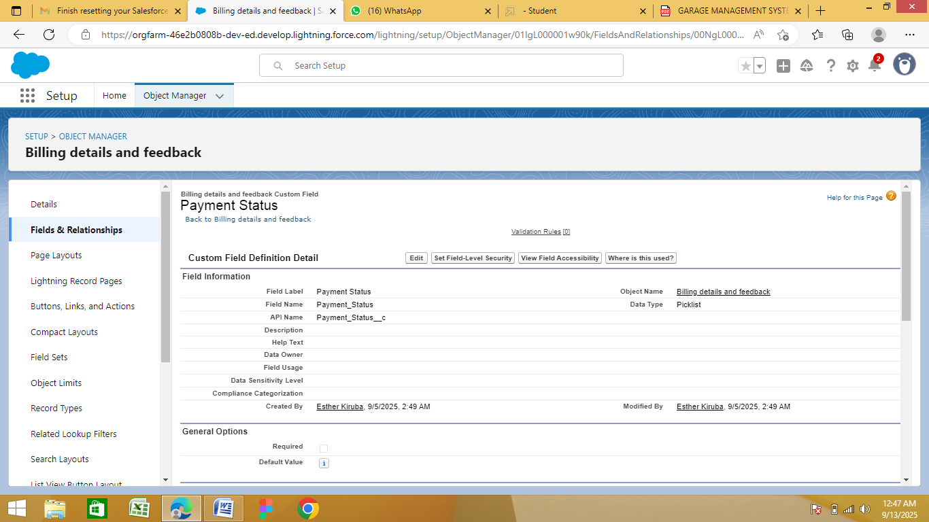

**●Creating Formula Field in Service Records Object:**

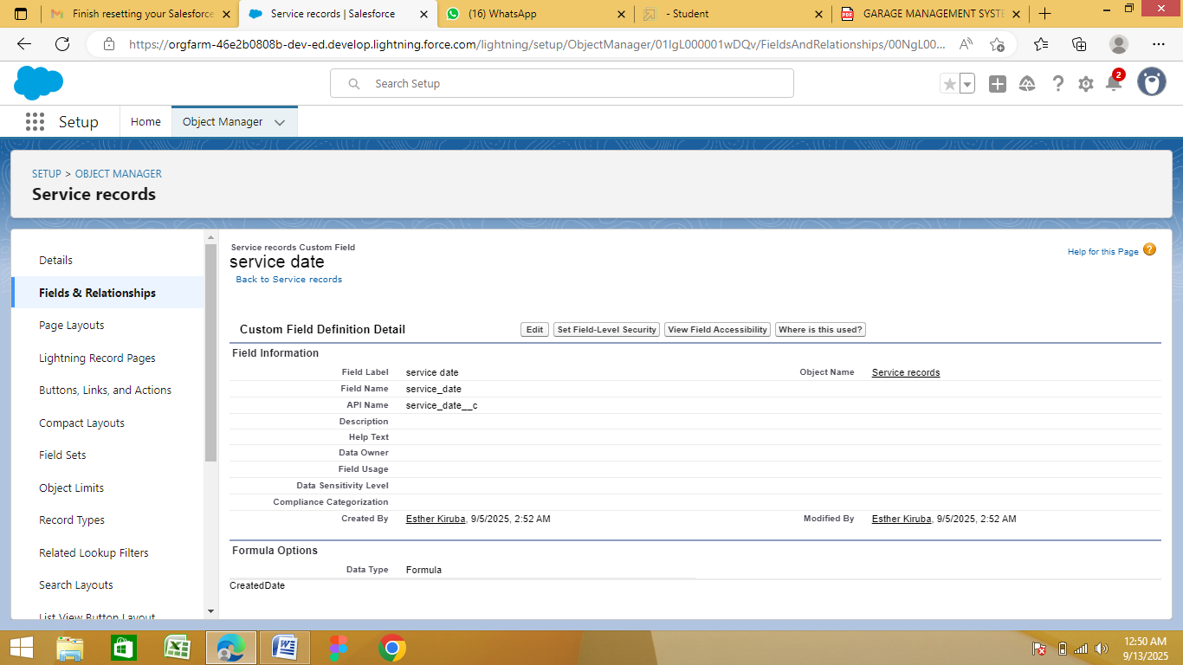

**●To Create a Validation Rule to an Appointment Object:**

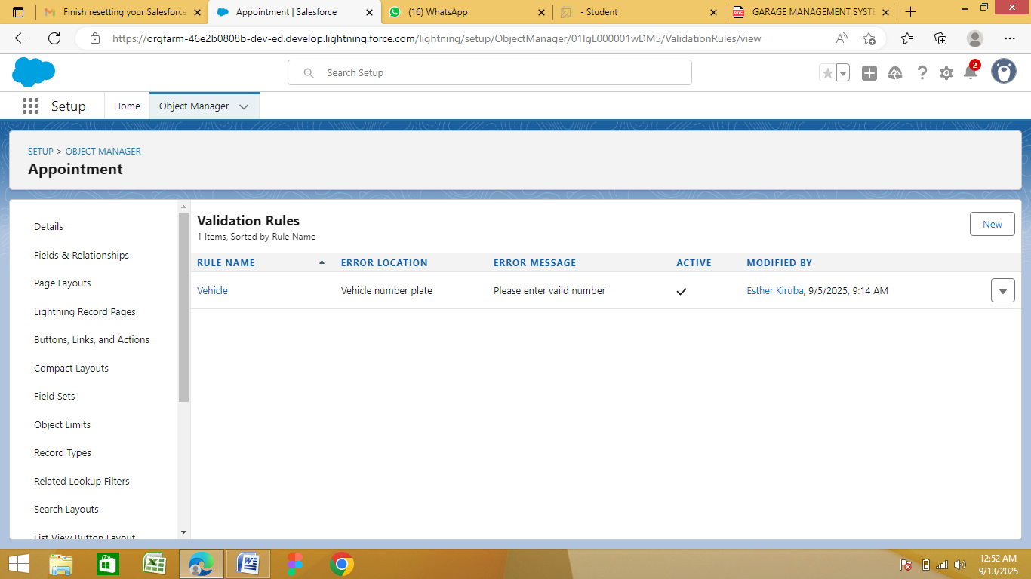

**●To Create a Validation Rule to and Billing Details and Feedback Object:**

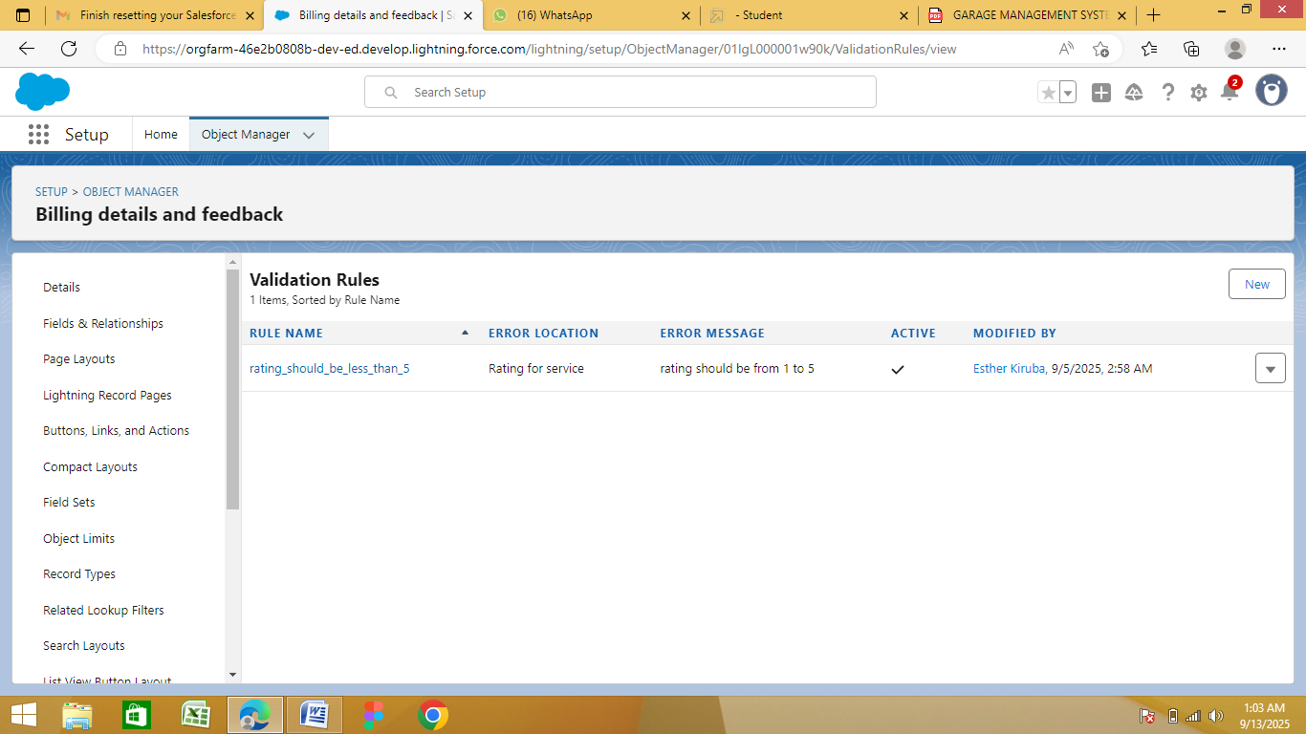

**●To Create a Matching Rule to a Customer Details Object:**

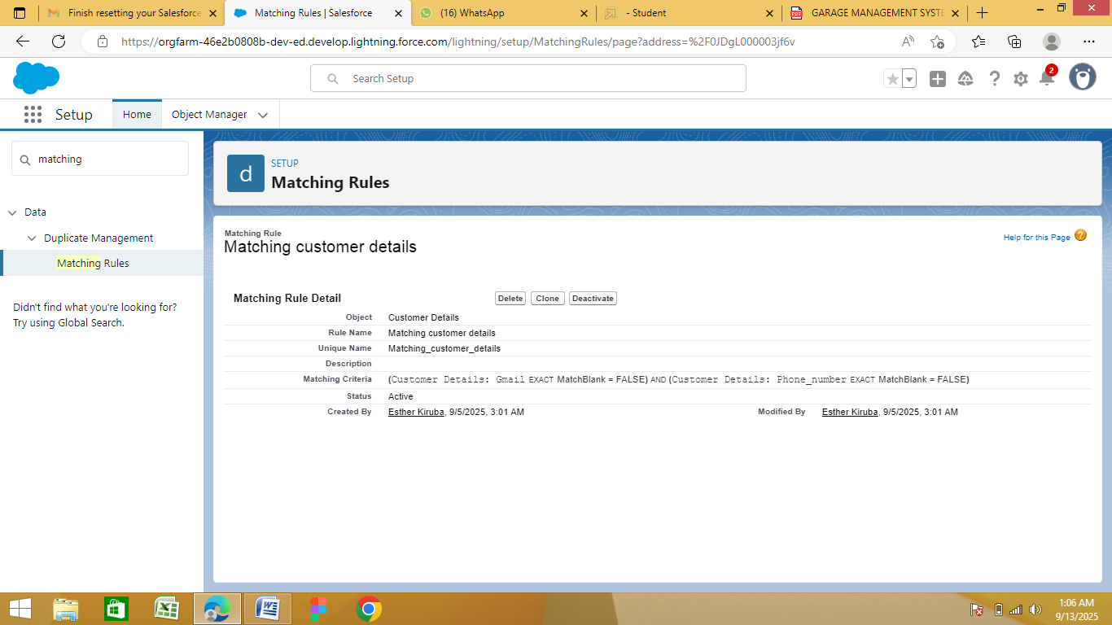

**●To Create a Duplicate Rule to a Customer Details Object:**

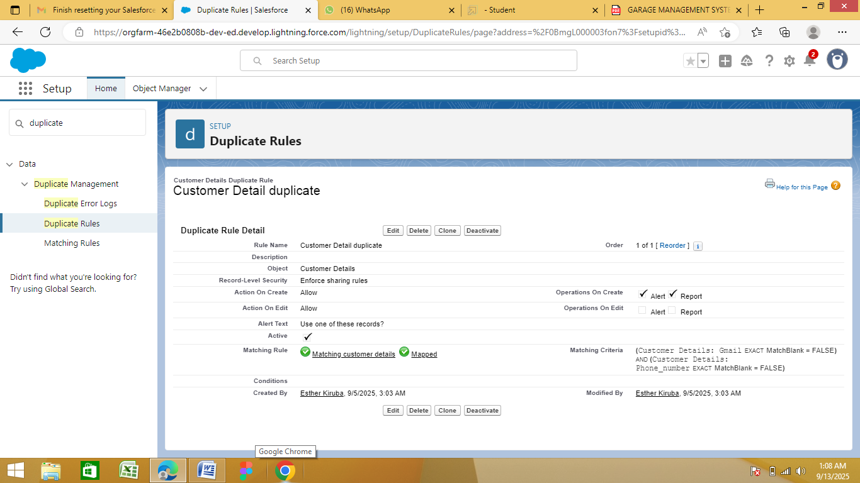

**●Manager Profile:**

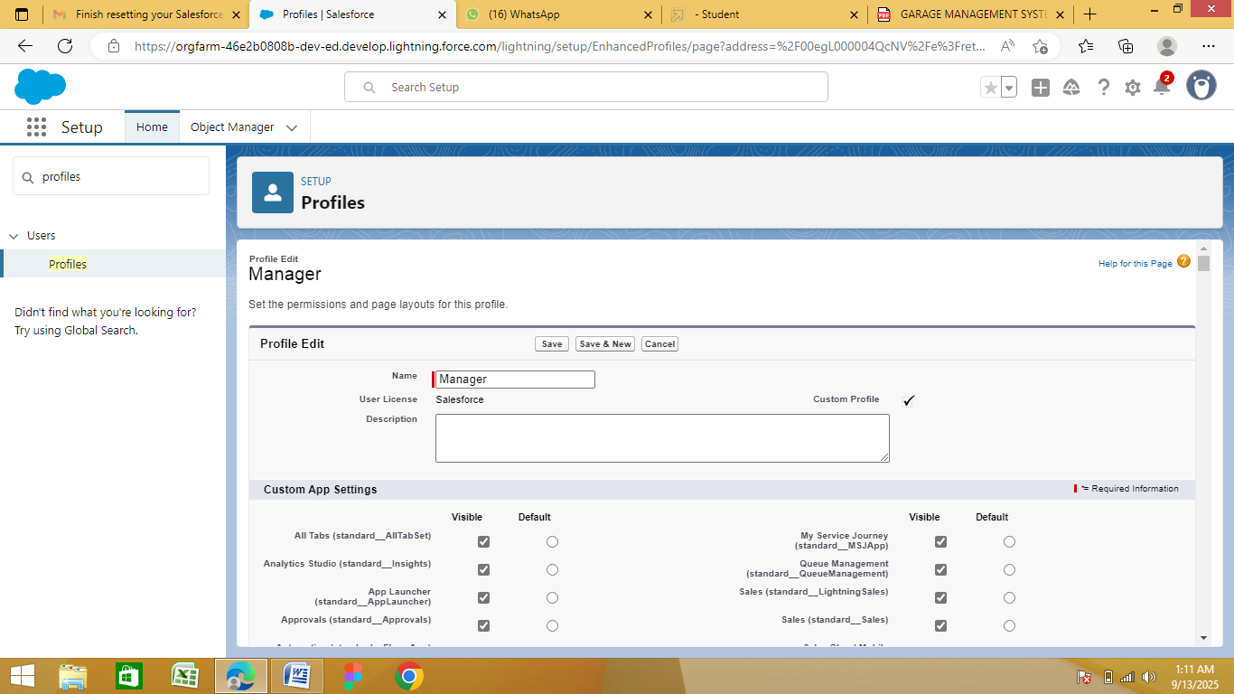

**●Salesperson Profile:**

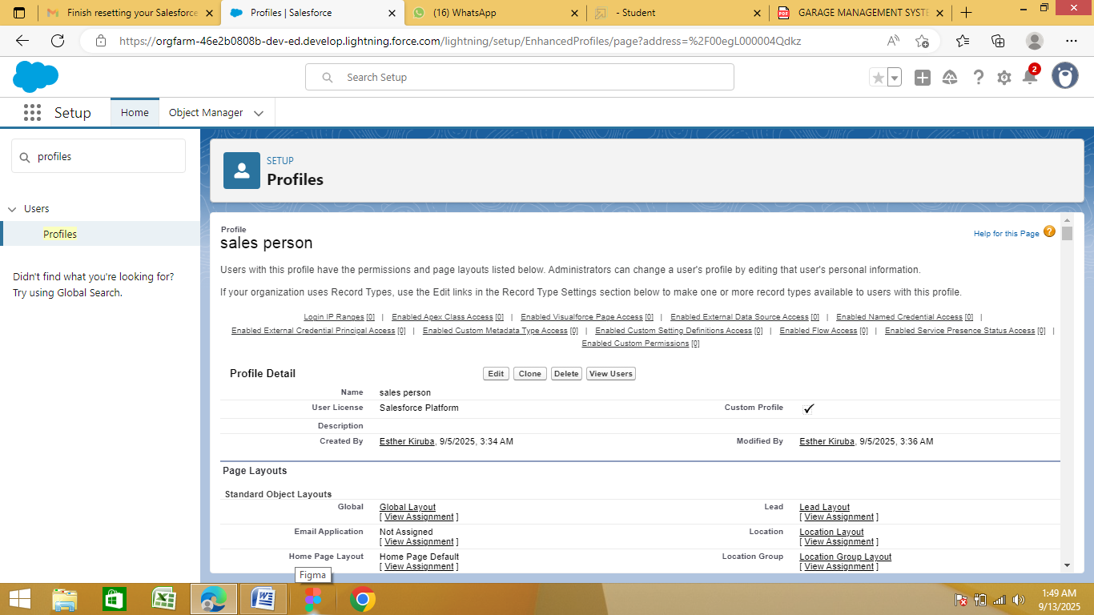

**●Creating Manager Role:**

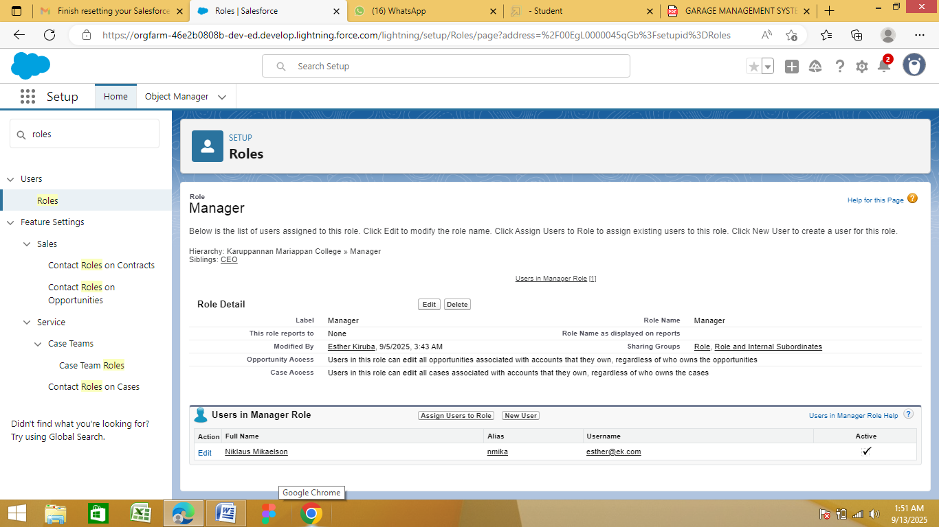

**●Creating Another Roles:**

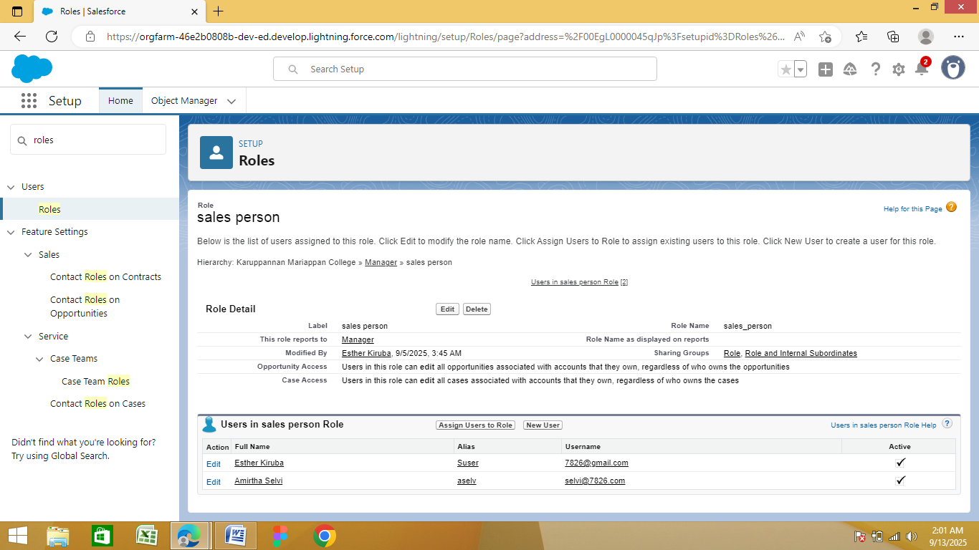

**●Create User:**

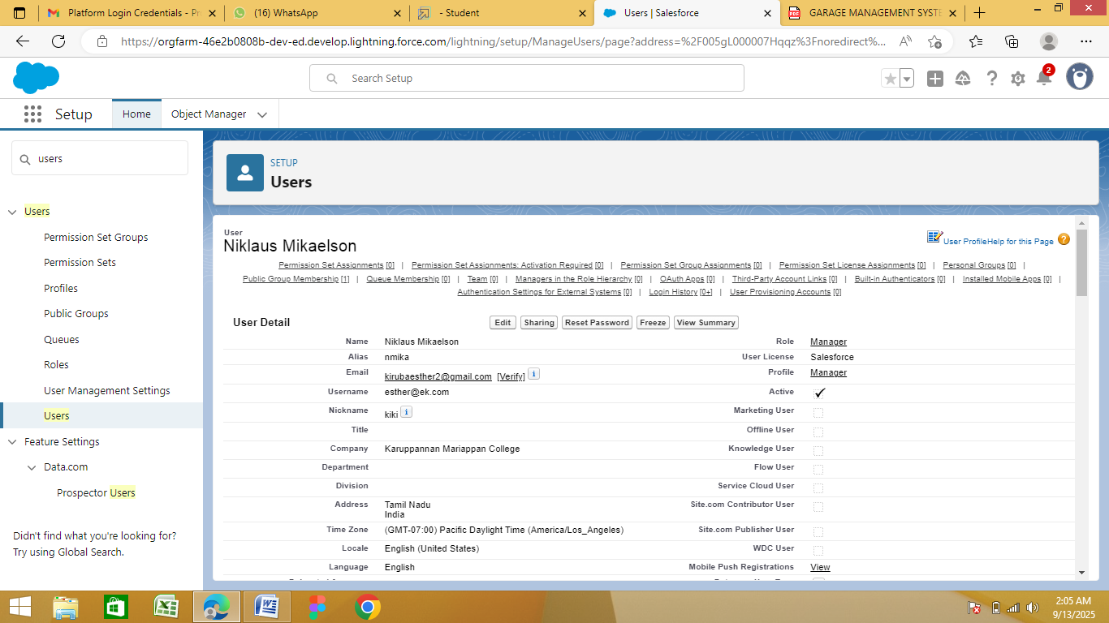

**●Creating Another Users:**

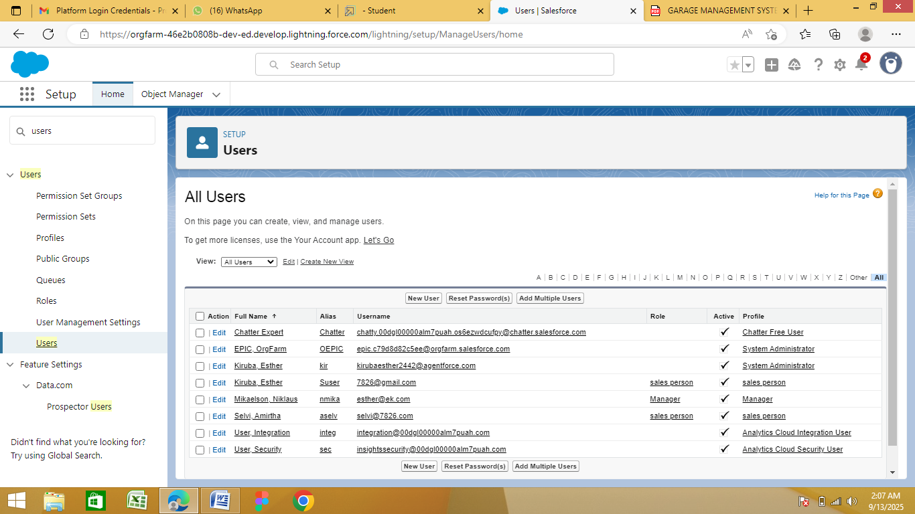

**●Creating New Public Group:**

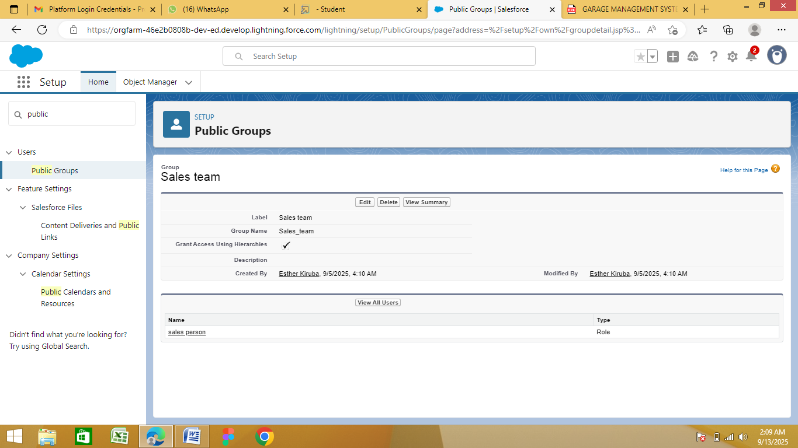

**●Creating Sharing Settings:**

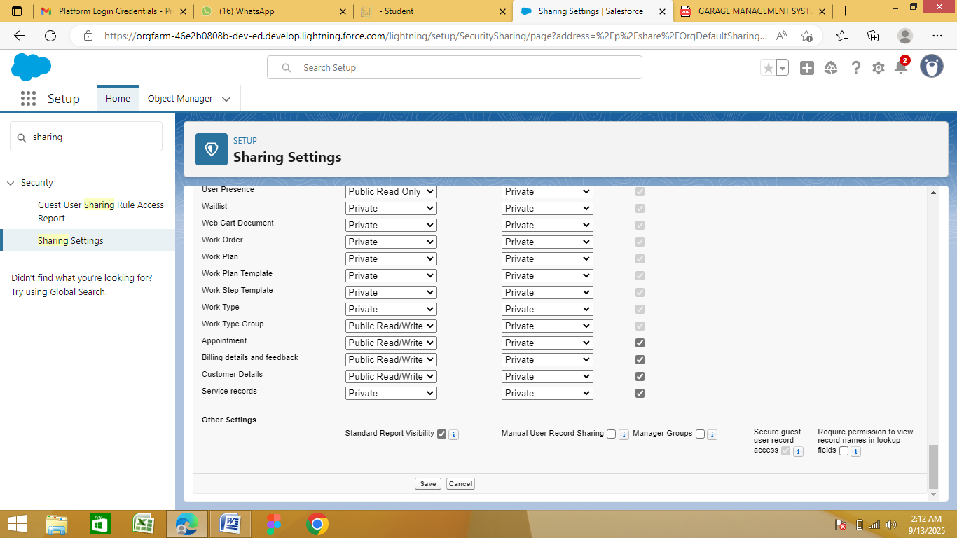

**●Create a Flow:**

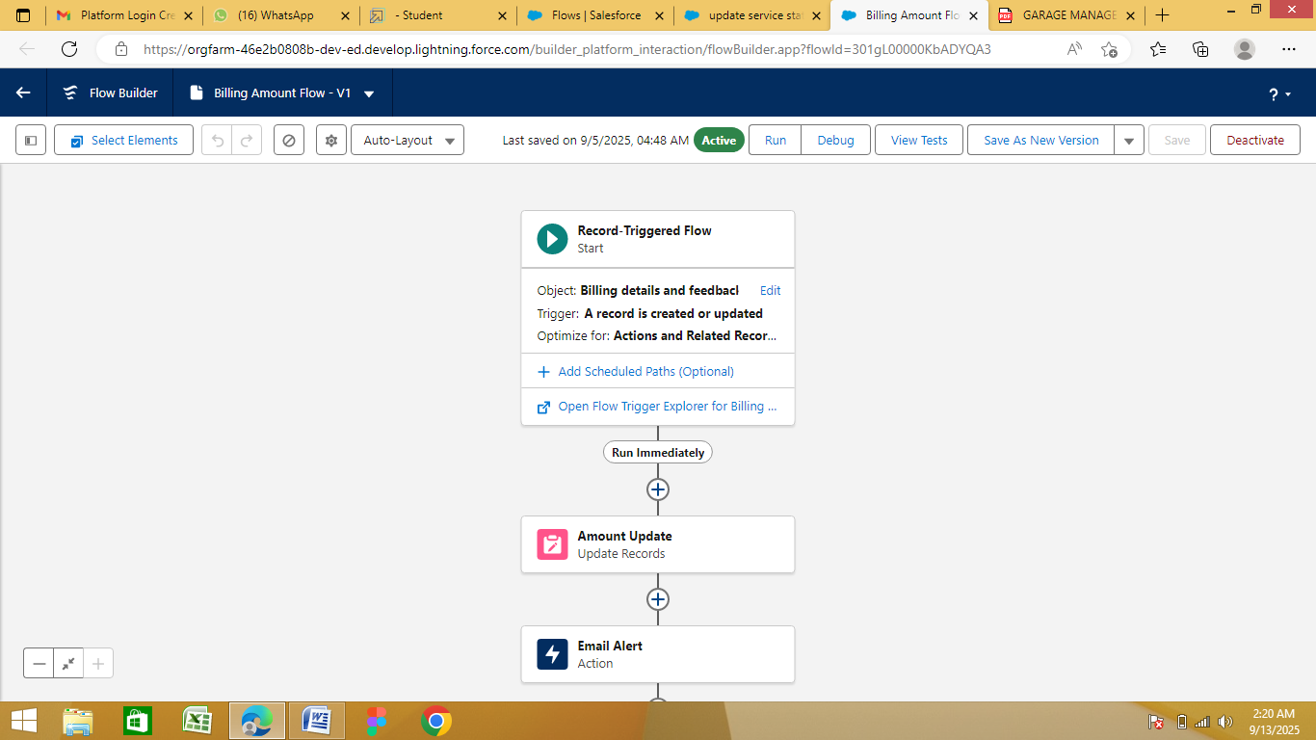

**●Create Another Flow:**

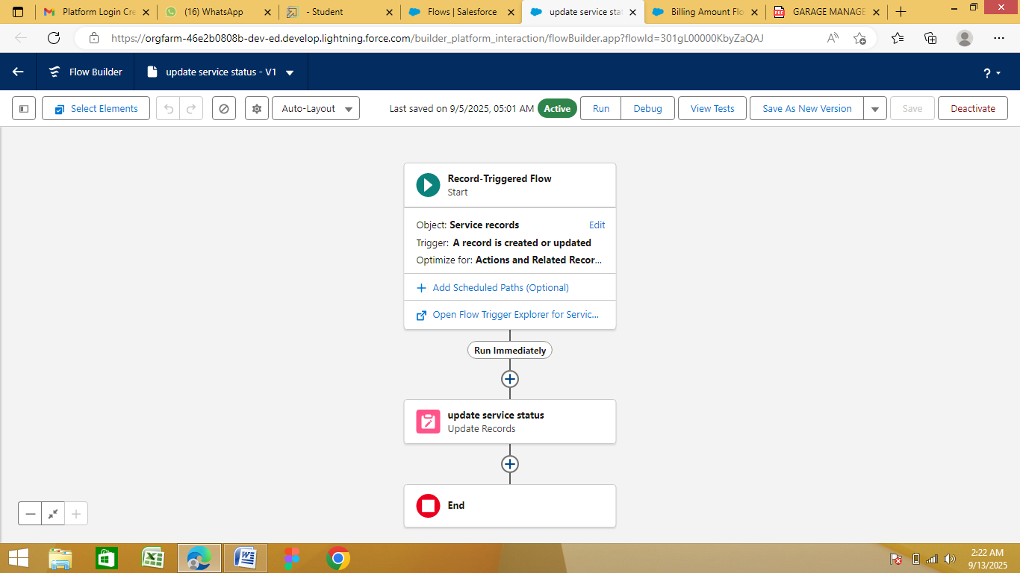

**●Apex Handler:**

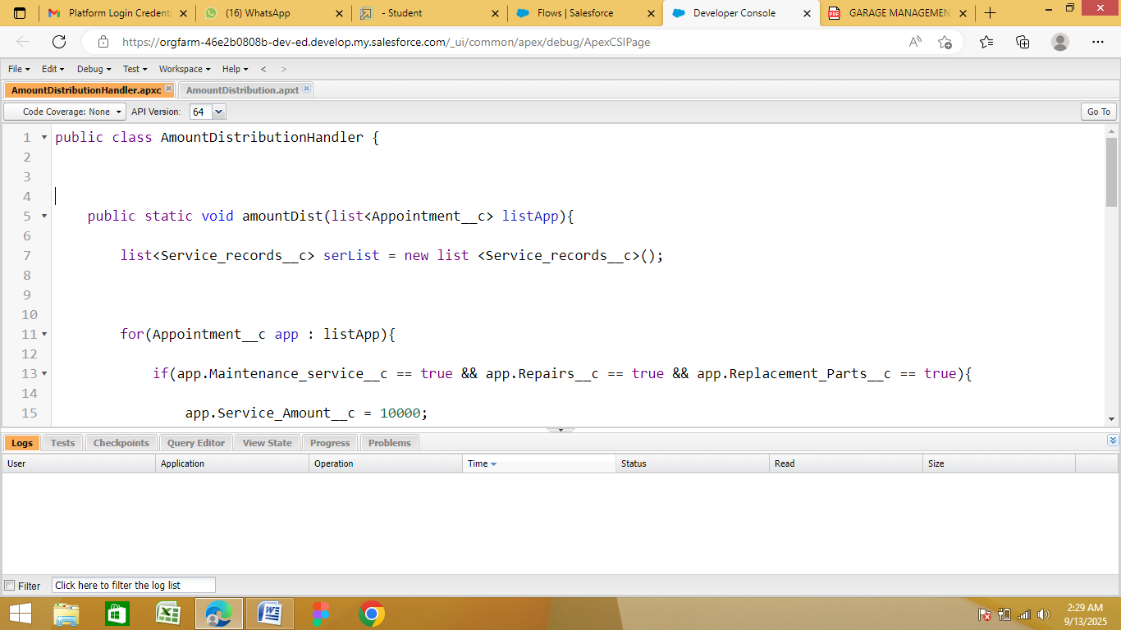

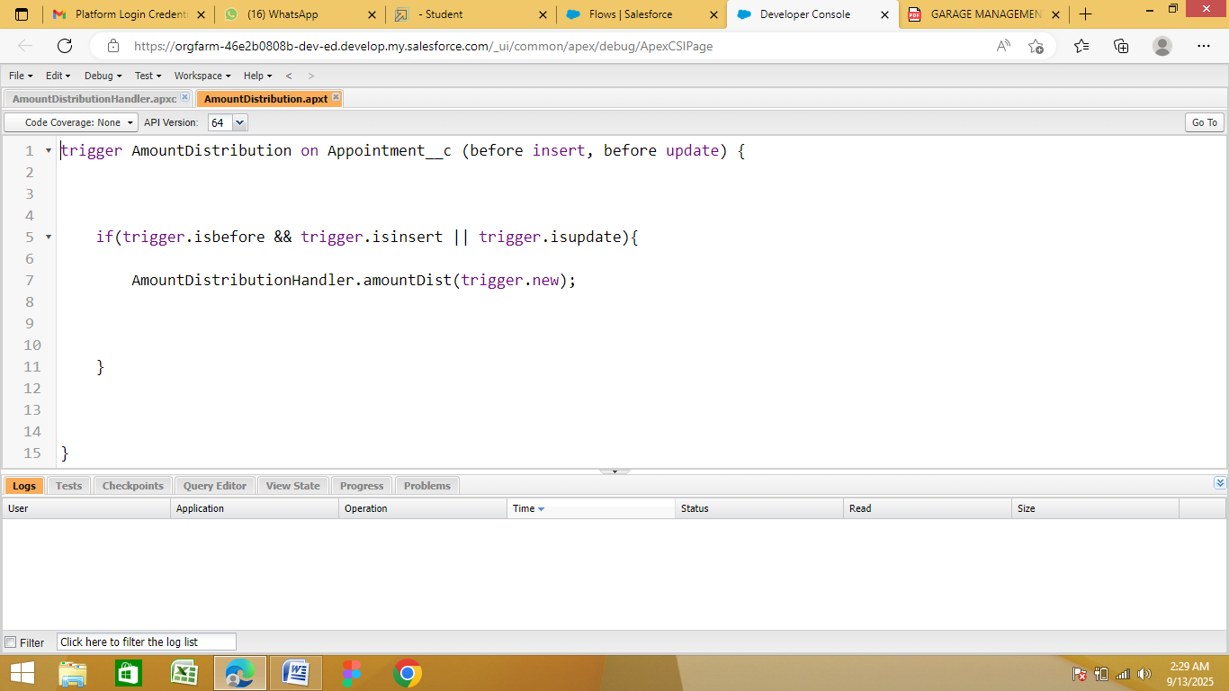

**●Create a Report Folder:**

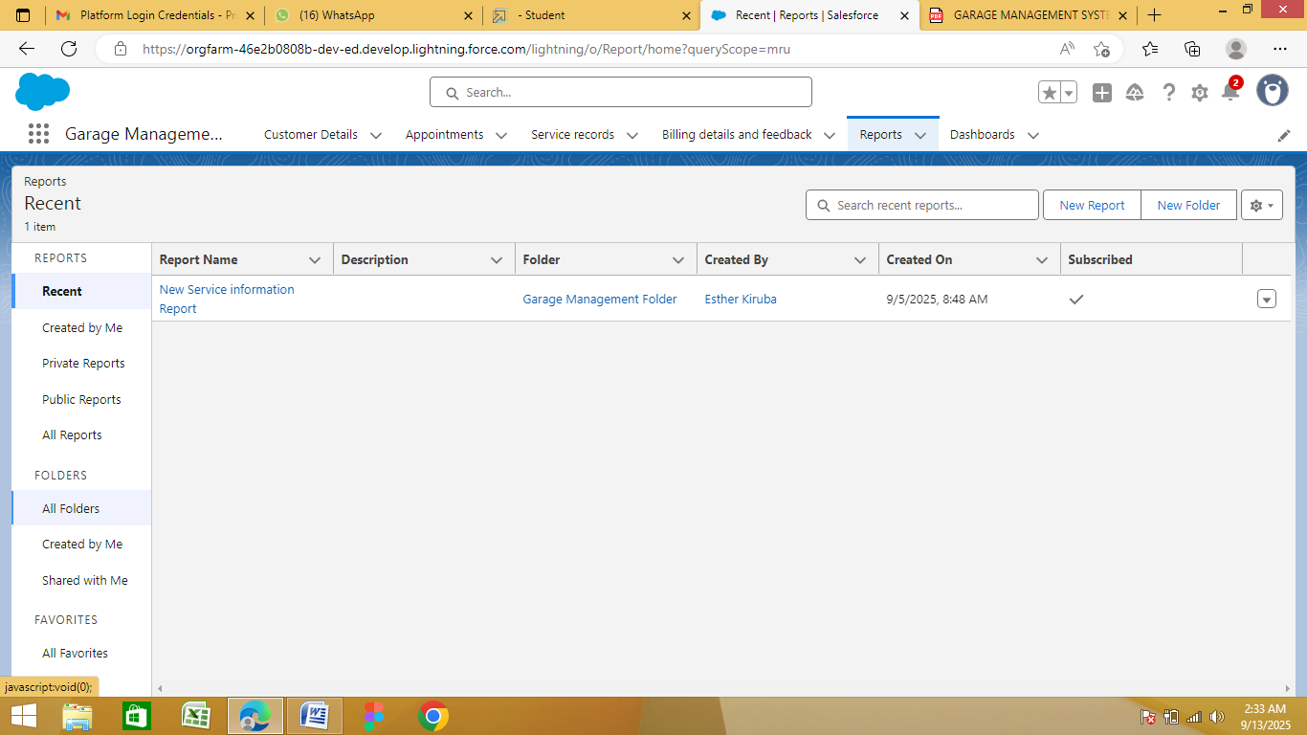

**●Sharing a Report Folder:**

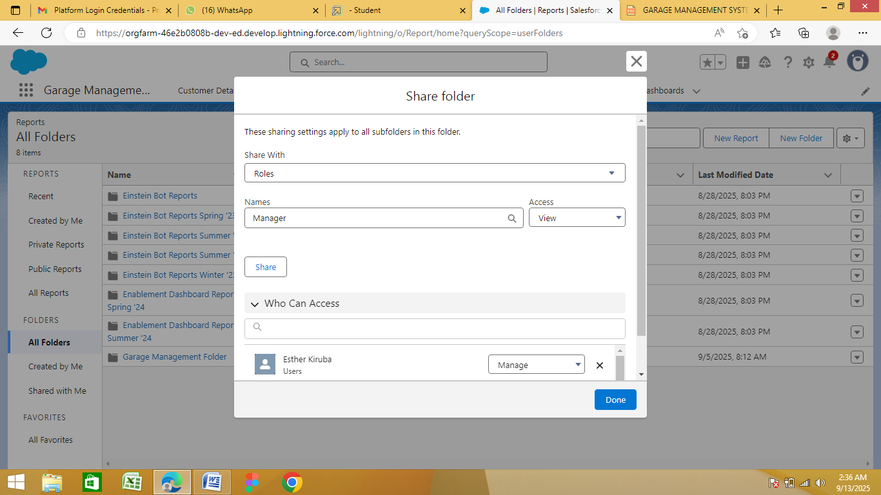

**●Create Report Type:**

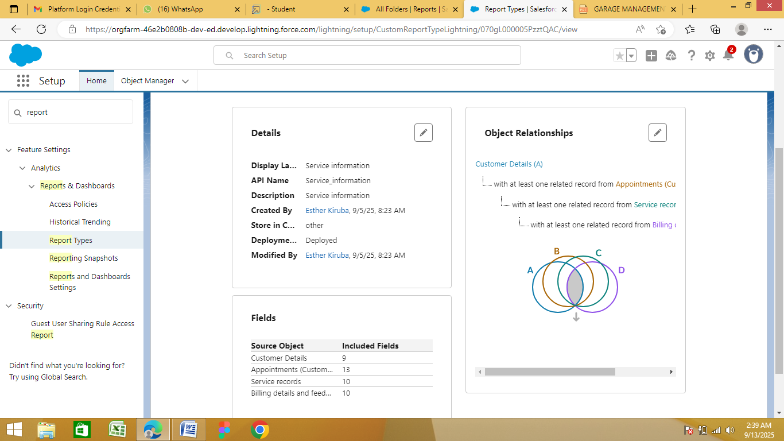

**●Create Report:**

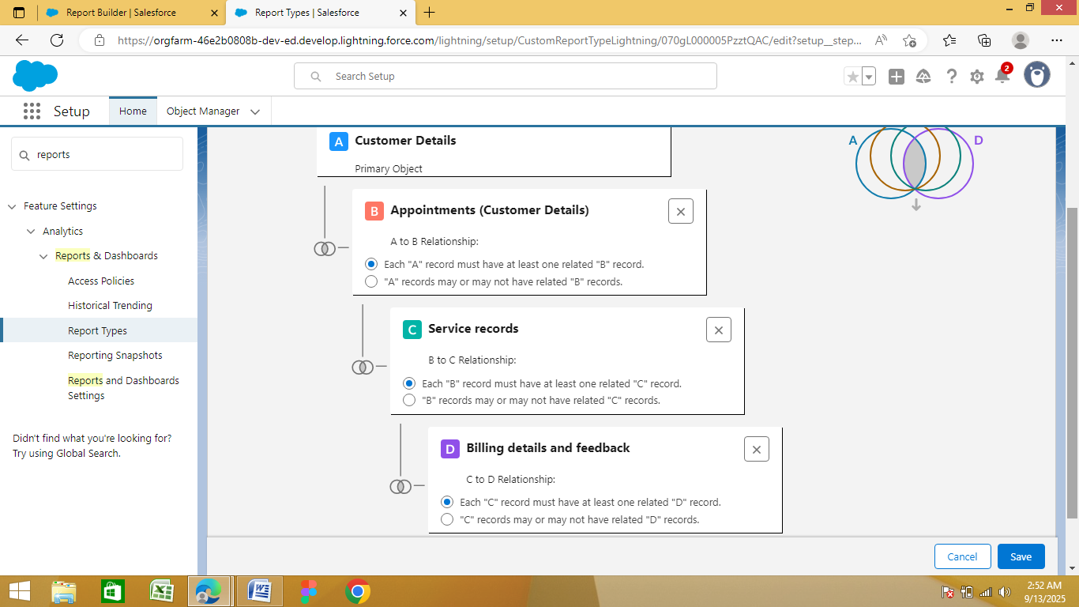

**●Create Dashboard Folder:**

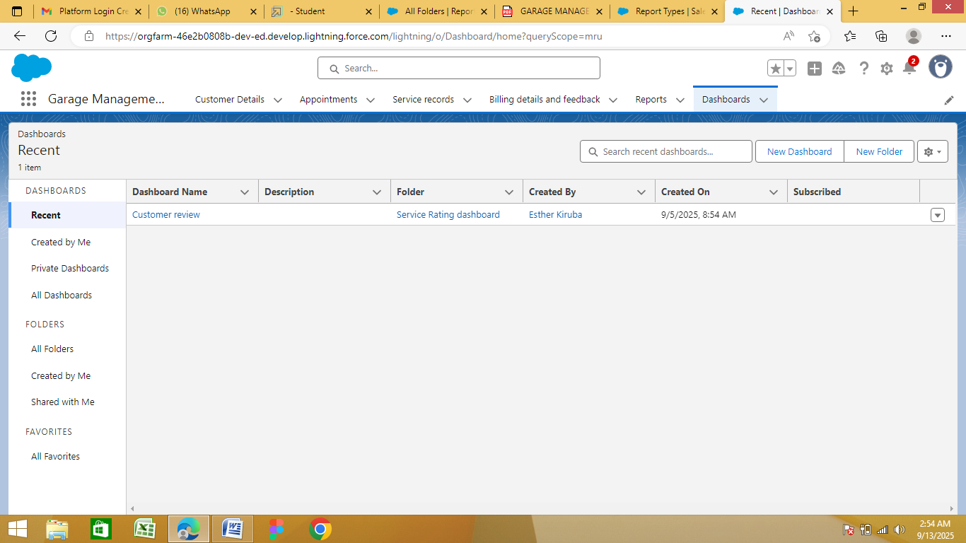

**●Create Dashboard:**

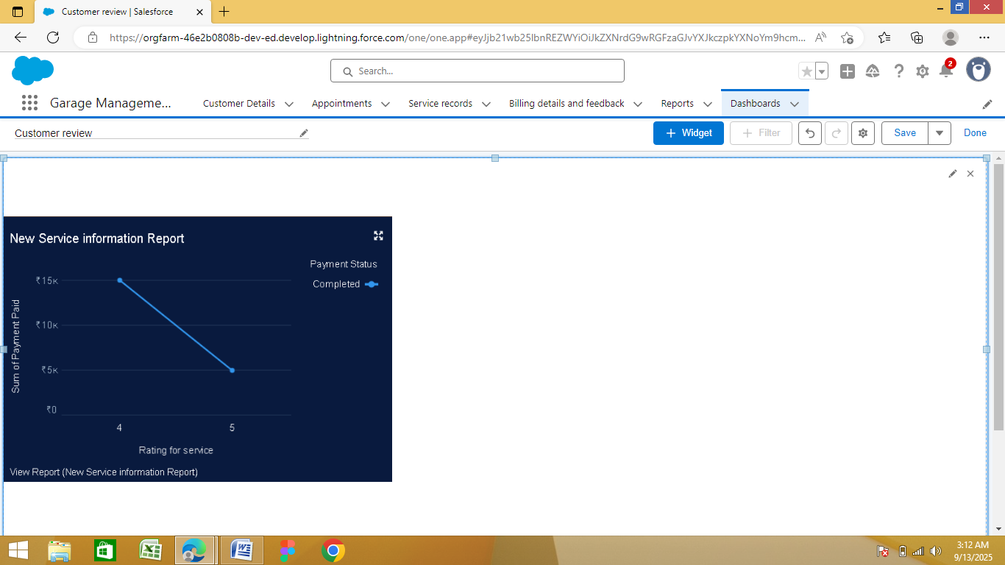

**●Creating Records:**

